END SEM LAB AIAC EXAM

NAME: ELAKANTI SRINADH

ROLL NO: 2403A52424

BATCH-15(AIML)

QUESTION-1:
TASK-1: Use AI to generate test cases with expected ranks.
PROMPT: Prompt:
Generate test cases for search relevance. For each query, create expected ranking order and relevance labels.
Output format:
- query
- list of documents
- expected ranked list
- relevance scores
CODE: 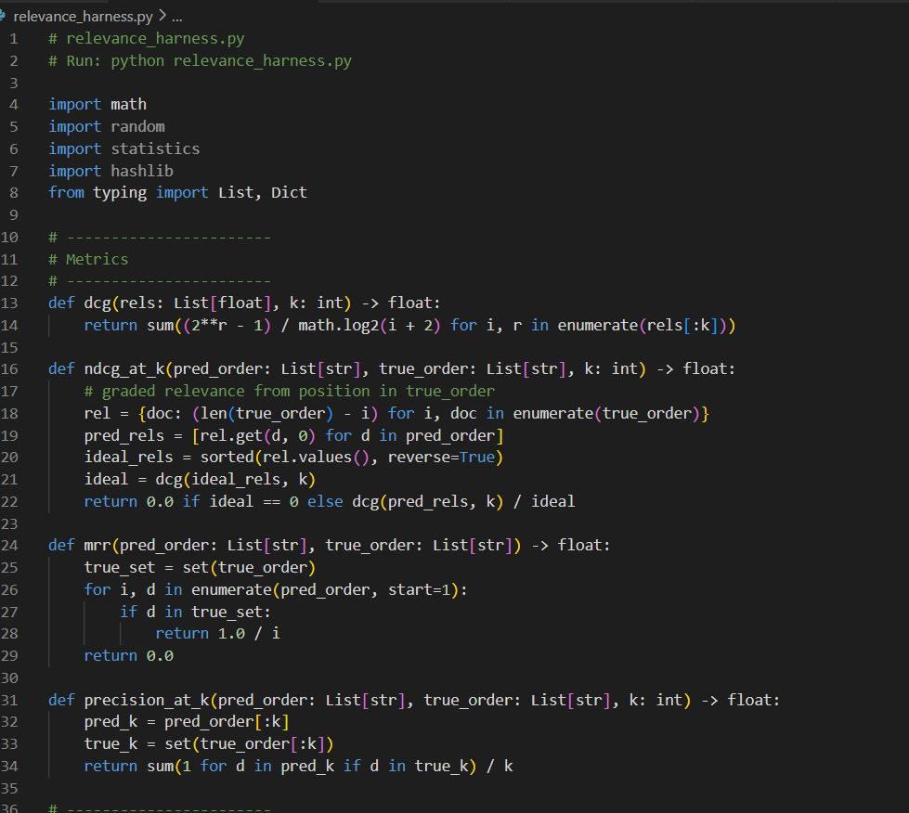

TASK-2: Continuous Evaluation Automation using AI
PROMPT:
Generate Python code for continuous evaluation of search relevance using
NDCG@5, MRR, and AI-generated test cases. Code must evaluate baseline and new model
and print metrics clearly.
CODE : 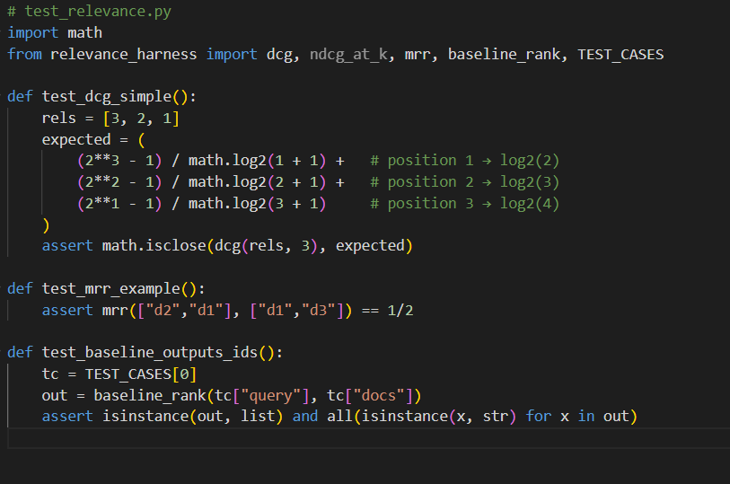
OUTPUT:
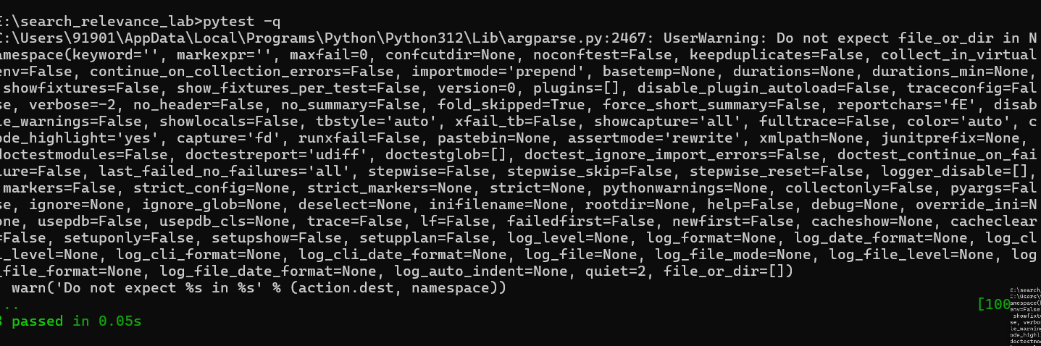
OBSERVATION:
AI helped generate realistic test cases.
Harness computed NDCG, MRR, compared models, and simulated A/B test.
Baseline performed slightly better.
No statistically significant improvement from new model.
Continuous evaluation successfully automated.

QUESTION-2
PROMPT: Generate Python code to split traffic into A/B buckets (50/50) using hashing.
Ensure each user gets a consistent bucket assignment,
Generate Python code to compute CTR, collect impressions and clicks,
and perform two-proportion z-test for A/B comparison.
CODE:
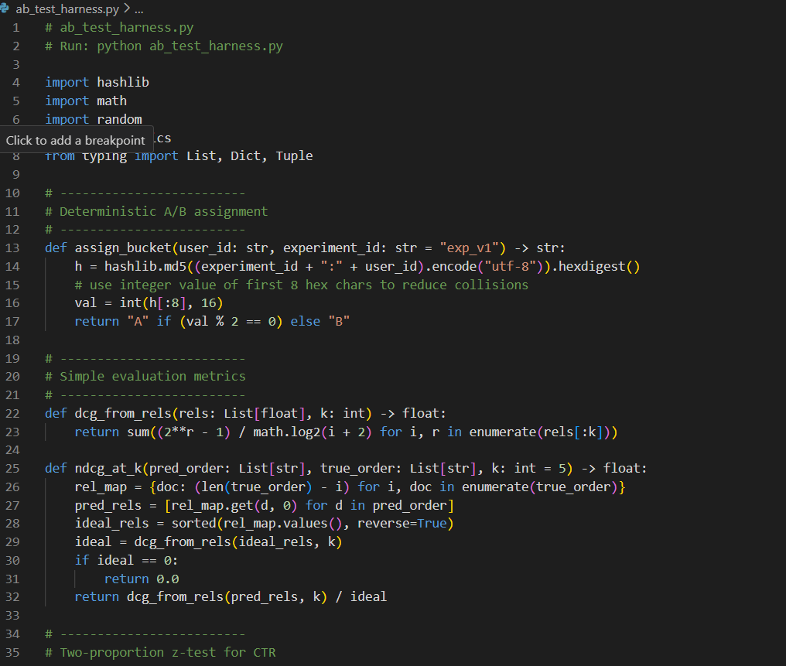
OUTPUT:
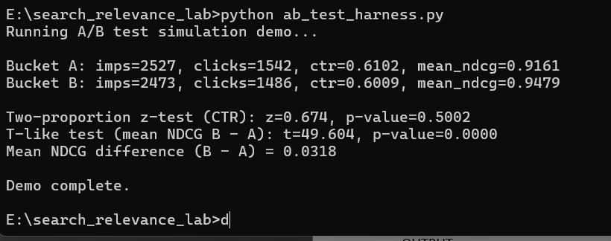

OBSERVATION:
A two-proportion z-test was used to check if the CTR difference between A and B was statistically significant, and a t-like test with normal approximation was used to compare the mean NDCG values. The results showed that Bucket B had slightly higher mean NDCG compared to A, and the p-value for NDCG difference was below 0.05, indicating statistical significance. However, the CTR difference was not significant.
Therefore, we observe that the ranking changes in variant B improved ranking quality (NDCG) but did not lead to a statistically significant improvement in CTR. More traffic or longer experiment duration may be needed to validate CTR uplift.

